Useful numeracy websites to help your children learn and have fun at home:

<https://www.mathsisfun.com/games>

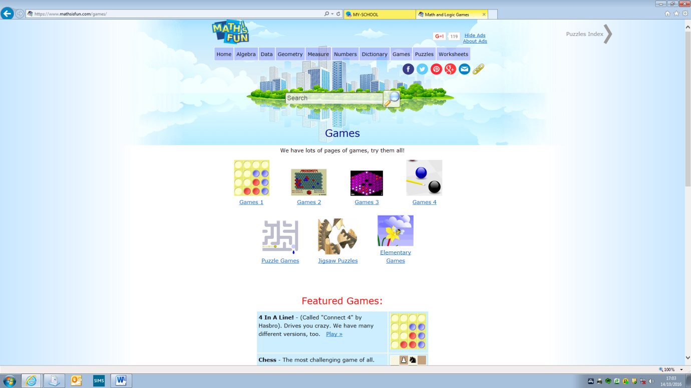

[www.topmarks.com](http://www.topmarks.com)

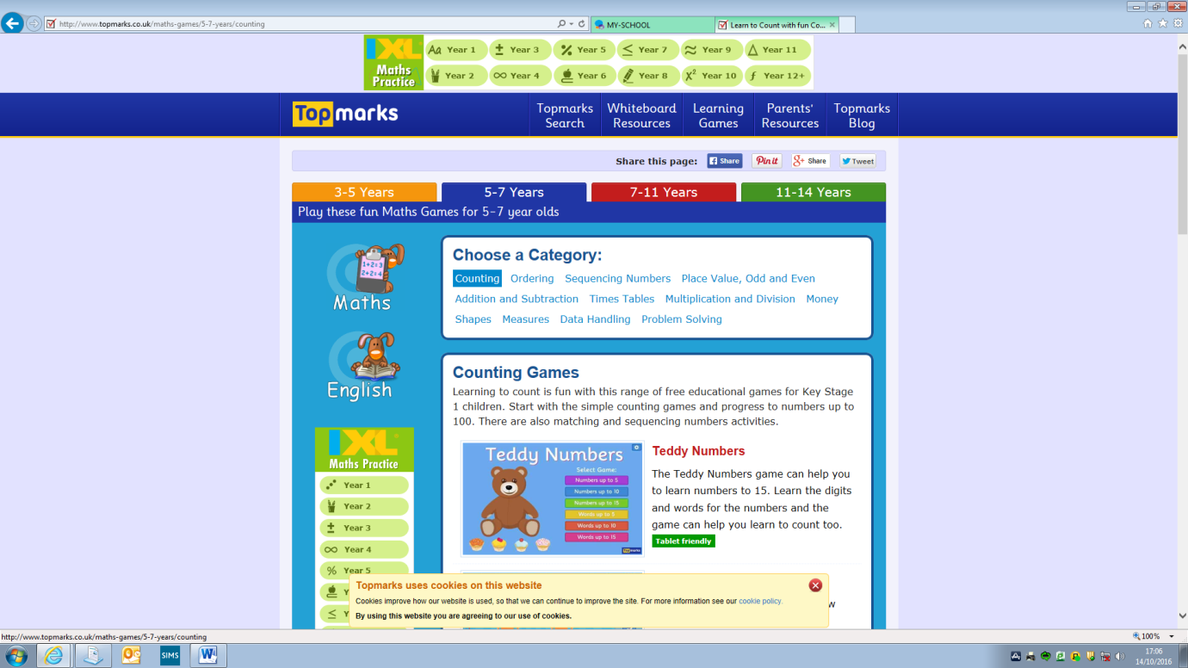

[www.nrich.maths.org](http://www.nrich.maths.org)

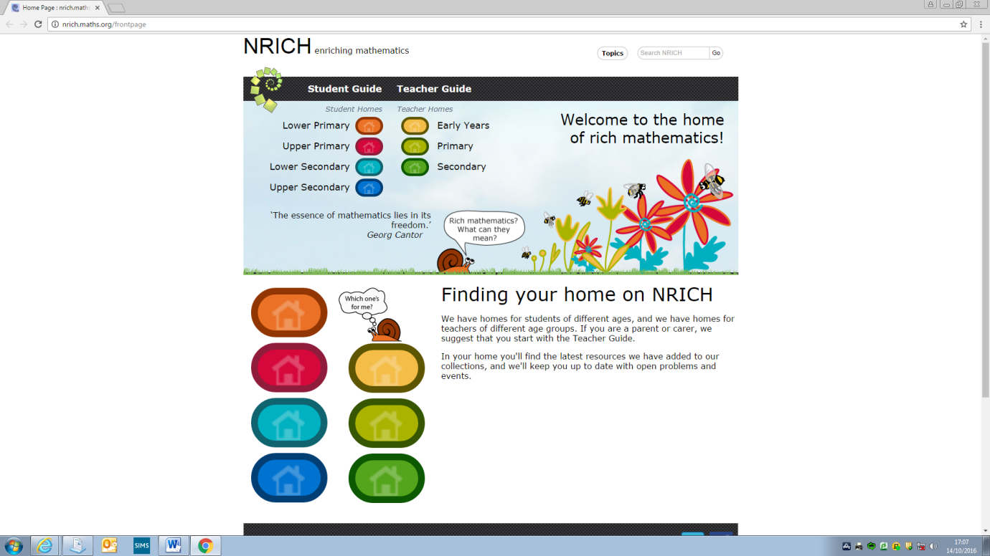

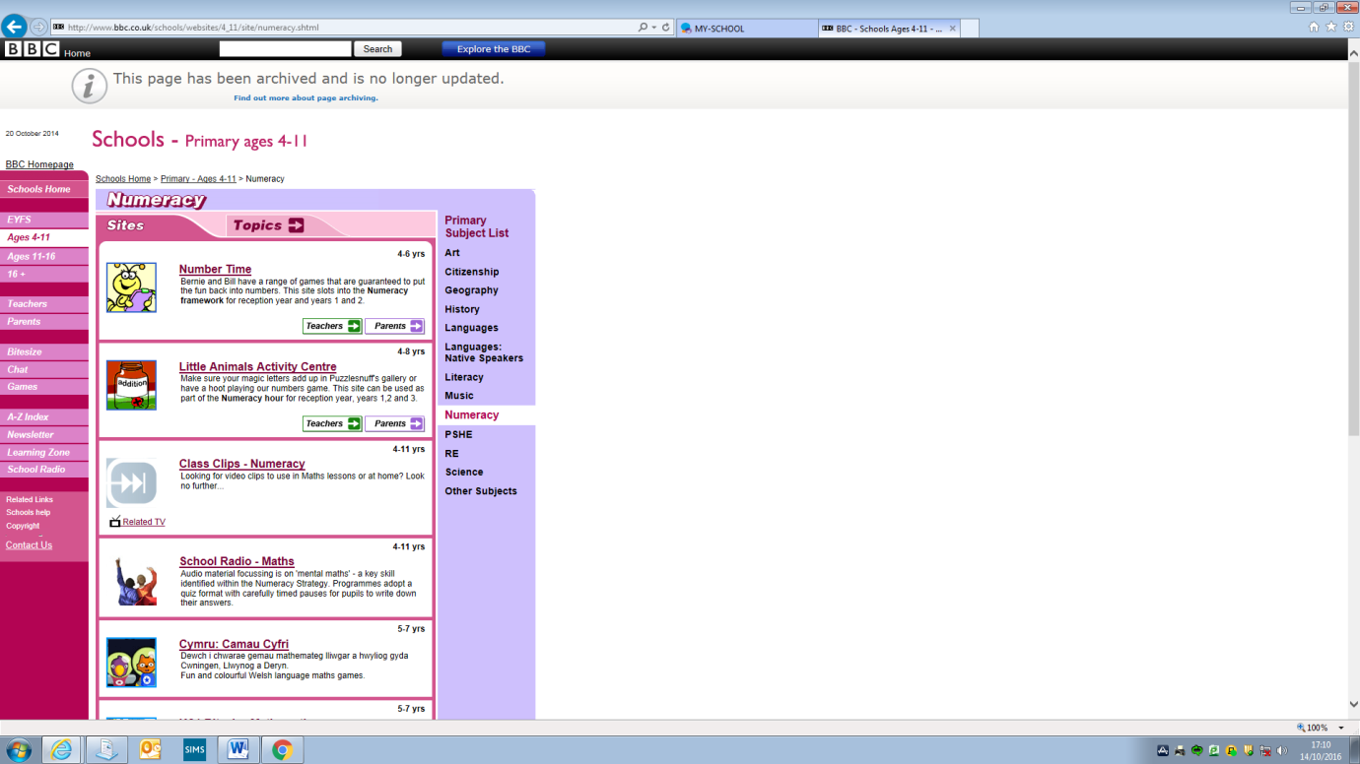[www.bbc.co.uk/interactive](http://www.bbc.co.uk/interactive)

[www.ictgames.com](http://www.ictgames.com)

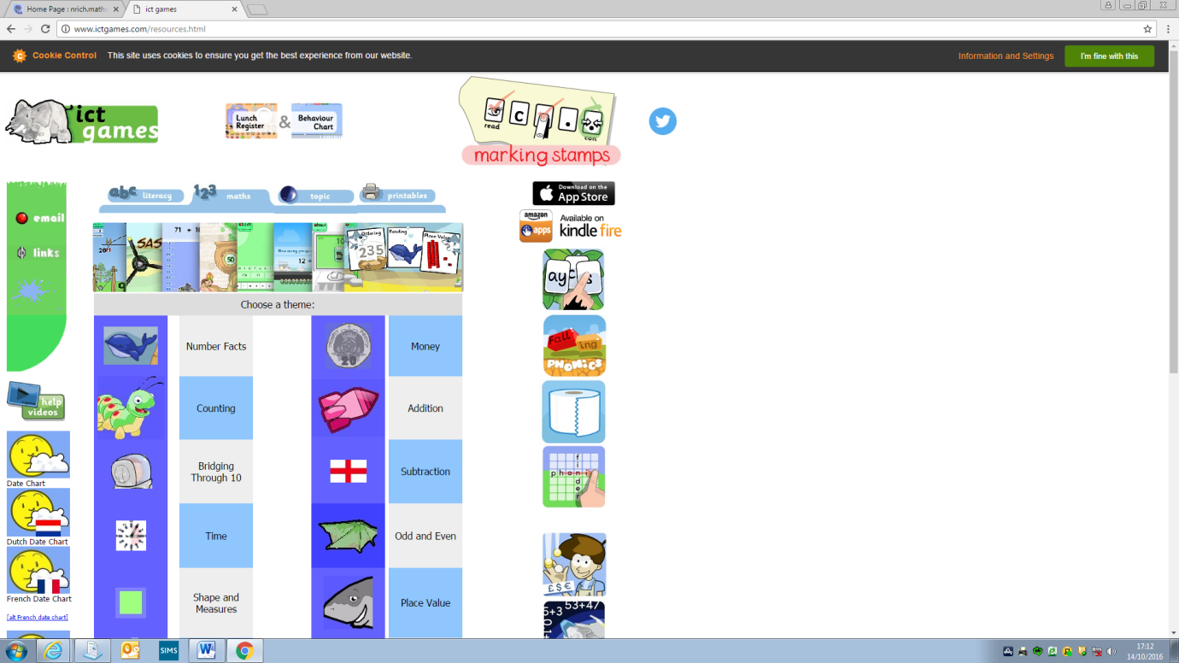

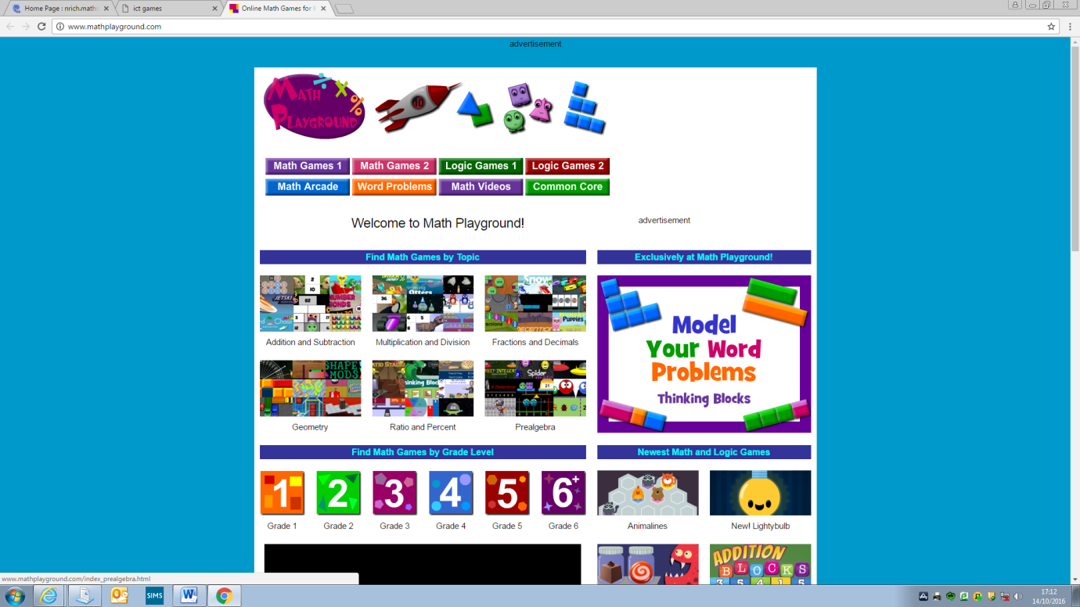[www.mathplayground.com](http://www.mathplayground.com)

[www.coolmaths.com](http://www.coolmaths.com)

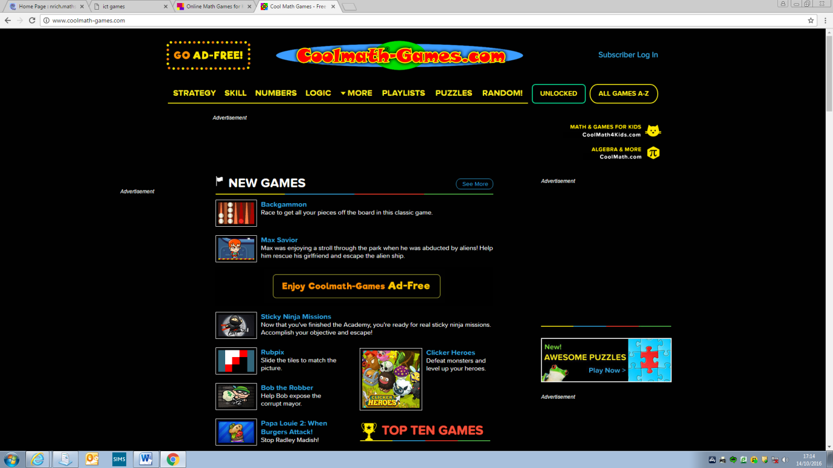

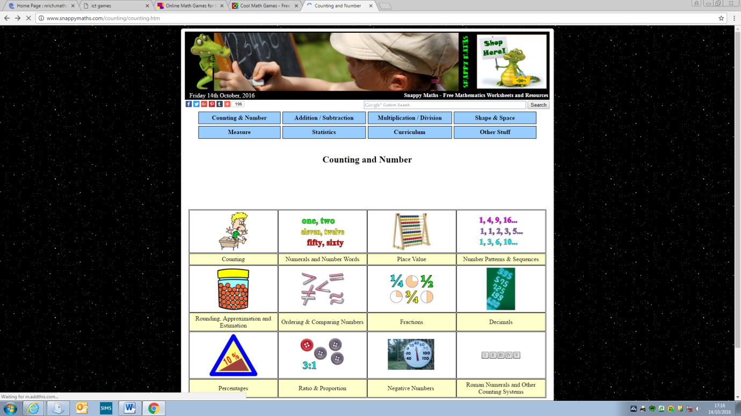[www.snappymaths.com](http://www.snappymaths.com)