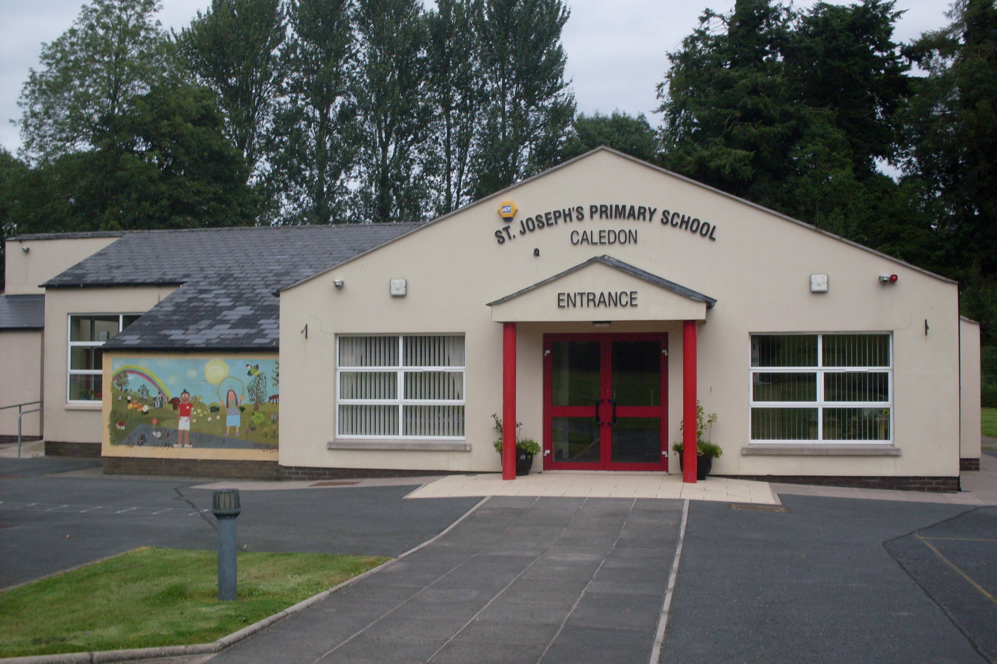

St. Joseph’s Primary School,
14, Derrycourtney Road,
Caledon,
Co. Tyrone
BT68 4UF
Tel: 37568537
Principal: Mrs Marie McKenna

St Joseph’s Primary School

Dear P1 Parents
We are delighted that your child will be coming to St Joseph’s PS in September.
I have held off contacting you as I await direction from the Department of Education with regard to opening the school in September.
I am pleased to say- as it stands- we will be able to have all of our children back full time AND will be able to ensure a metre apart distance between the them.
We would like to invite your child to attend for their INDUCTION DAY on Tuesday 25th August from 9-12. After this, they will be in for the full day of 9- 3pm.
At this stage, I don’t have any information regarding school transport or school dinners.
I am sure you will understand that the children’s start will not be the usual ‘hands-on’ experience and that we are obliged to implement a number of protocols to ensure we comply with health regulations. I will outline these in greater detail later.
With regard to uniform, we have a number of school jumpers available. We will be here on Monday 29th and Tuesday 30th June to answer any of your queries. After these dates we will also be available from Monday 17th August.
Please be assured, it is our mission to ensure the children have a positive, enjoyable experience and that they will settle into routine quickly.
Yours sincerely,
M McKenna

